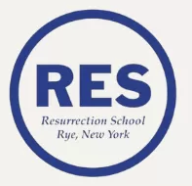

**Incoming Grade 8th Summer Reading List**

Required Summer Reading

**The Next Person You Meet in Heaven** by Mitch Albom

**A Long Walk to Water** by Linda Sue Park